**MongoDB Assignment**

1. Insert New Feedback. BASIC Input: Adding feedback for a customer and loan, capturing sentiments and details about the loan process.

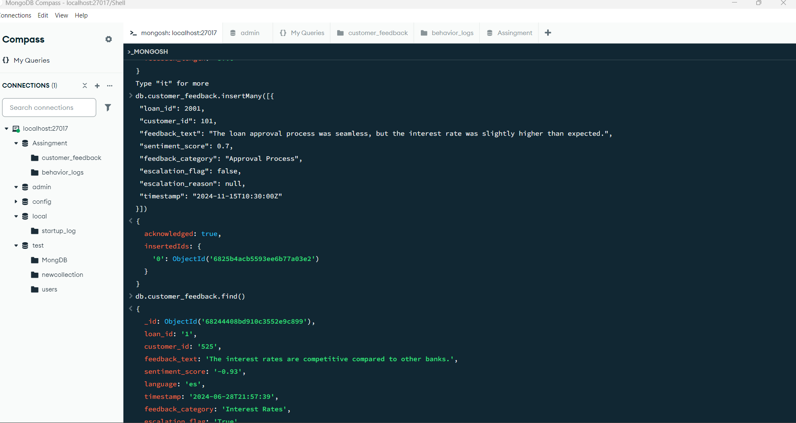

2. Update Escalation Flags. BASIC Input: Update escalation flags in feedback to include specific reasons for unresolved customer complaints.

4. Retrieve Positive Feedback. BASIC Input: Retrieve feedback entries with sentiment scores greater than 0.5.

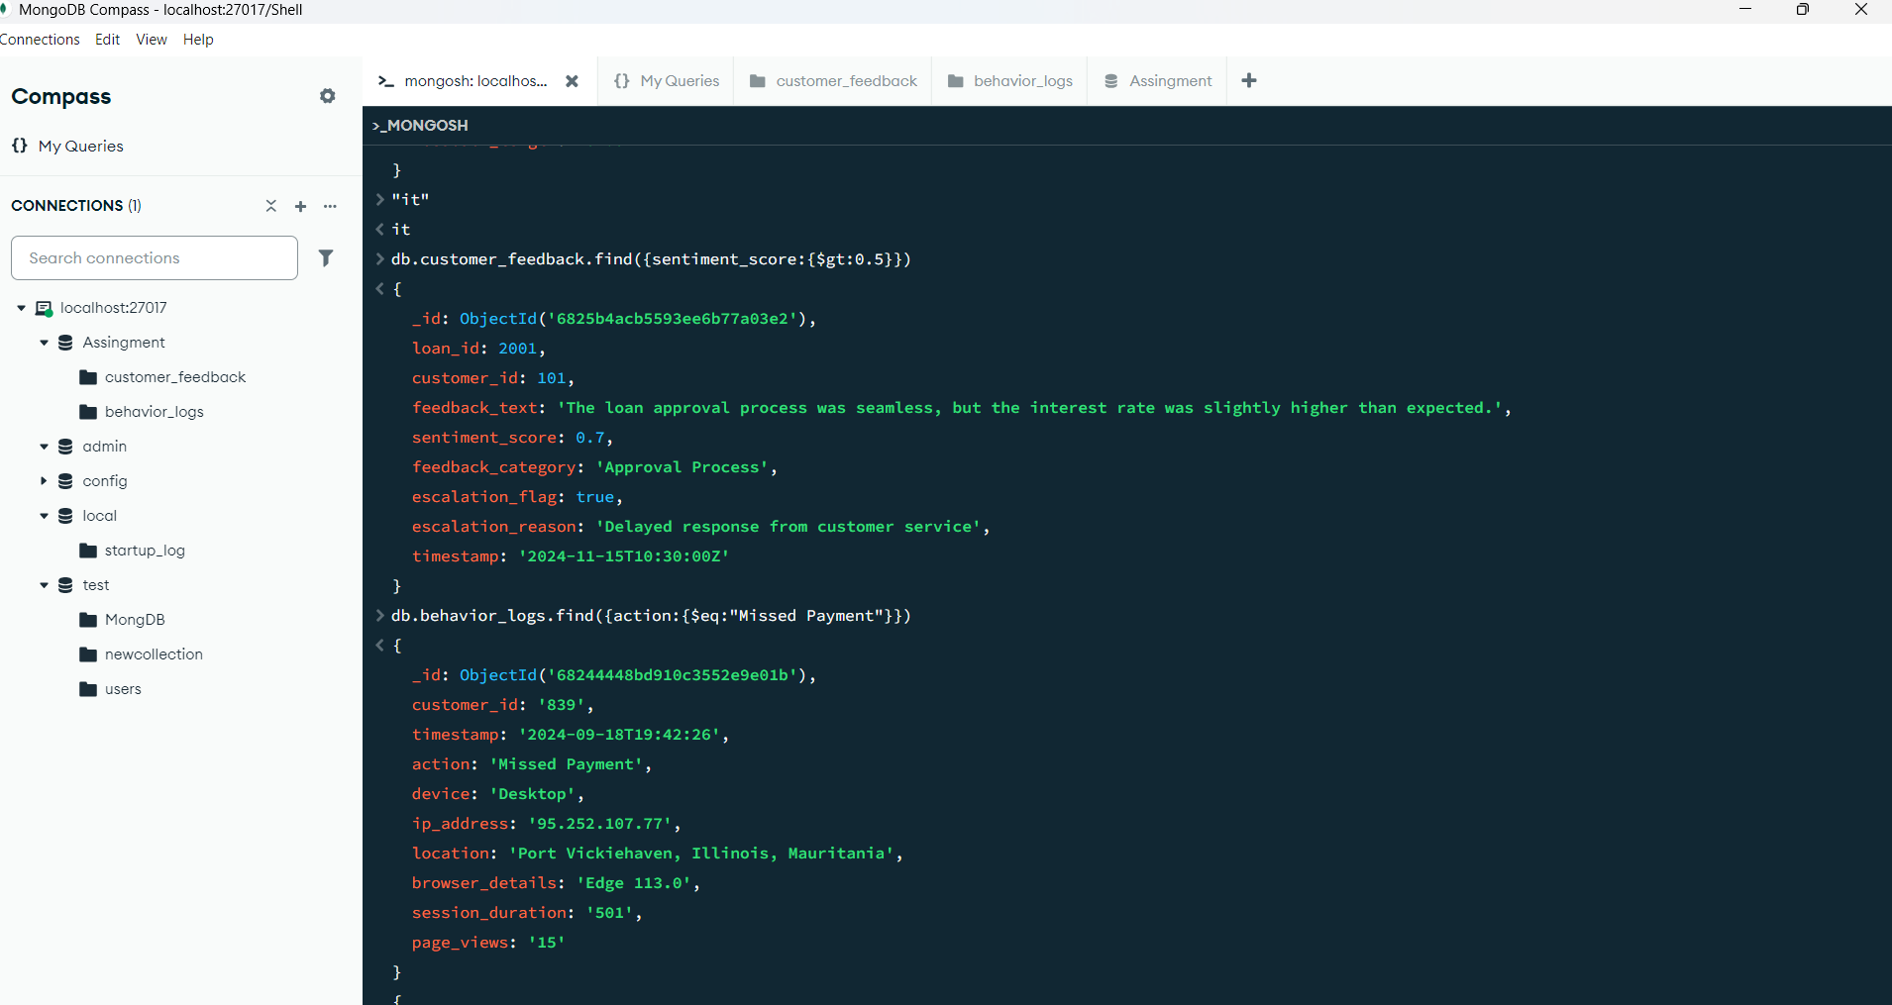

5. Fetch Logs for 'Missed Payment' Actions. BASIC Input: Retrieve behavior logs where the action is "Missed Payment."

